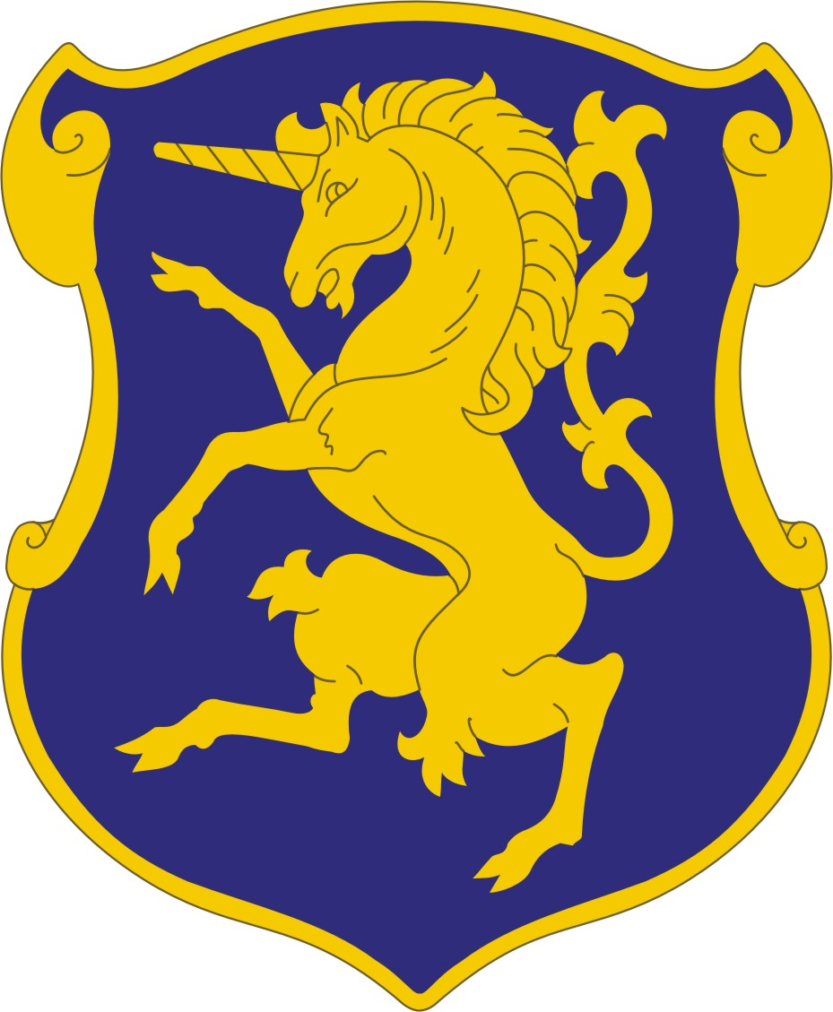
6th U.S. Cavalry Association
Membership Application
Annual Dues: $25
Lifetime Membership $250

6th U.S. Cavalry Association Objectives
To carry on the traditions, customs, memories and spirit of comradeship inspired by the mutual association of service of the 6th U.S. Cavalry.
To render assistance to member worthy Comrades, their widows and orphans.
To defend the honor, integrity, and supremacy of the United States and its Constitution.
To promote patriotism and good citizenship in our communities.

Please Print or Type

Last Name: ____________________________________________________________________
First Name: ______________________________________________Middle Initial __________
Address: ______________________________________________________________________
City: _________________________________________________________________________
State: ___________________________________________Zip Code: _____________________
Former Unit, Troop/Squadron: ____________________________________________________
_____________________________________________________________________________
Years of Service _______________________________________________________________
Daytime Phone Number: _________________________Cell: ___________________________
E-Mail Address: _______________________________________________________________

Make Check Payable to: 6th U.S. Cavalry Association
Mail to: PO Box 5488 - Fort Oglethorpe, GA 30742
Visit the 6th Cavalry Museum on the web at www.6thcavalrymuseum.org
Click on Association link for more information and photos

